Research and Feature Implementation Documentation

Arma Automotive Inc.

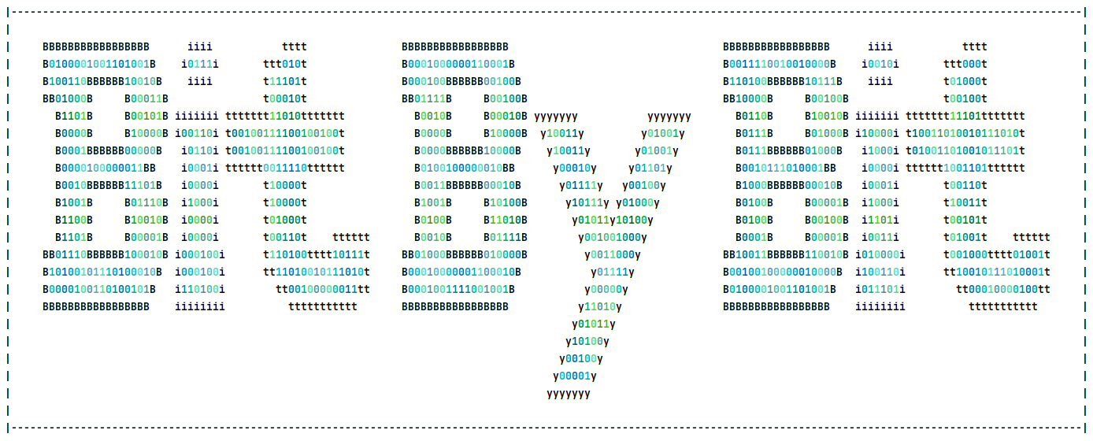

Prepared by Camosun Capstone team Bit by Bit:

Hanson C., Jaspal D. and Kento H.

Version 1.3

Dec. 05, 2024

# Version History

| **Version** | **Date** | **Description** | |
| --- | --- | --- | --- |
| 0.5 | Oct. 08, 2024 | Documentation started | |
| 1.0 | Nov. 15, 2024 | Initial research complete | |
| 1.1 | Nov. 24, 2024 | IEEE references added | |
| 1.2 | Dec. 01, 2024 | Revised based on feedback | |
| 1.3 | Dec. 05, 2024 | Added Feature Implementation Documentation | |

# Table of Contents

**Version History 1**

**Table of Contents 2**

**Document Purpose 1**

**CNC Machine 3**

What is CNC? 3

What is a CNC Machine? 3

What is a CNC Router? 3

What are Axes in a Router? 3

3-Axis Routers 3

4-Axis Routers 4

Index/ Simultaneous (also sometimes called Continuous) 4

5-Axis Routers 4

3+2 Axis/ Simultaneous 5-Axis (also sometimes called Continuous) 5

What is a CNC Mill? 5

What is the Difference Between a CNC Router and a CNC Mill? 5

Coordinate Systems for CNC Machines 6

3D Printers are CNC Machines? 6

Additive vs Subtractive Manufacturing 6

**G-Code 7**

What is G-Code? 7

How does it work? 7

Does G-Code differ between machines? 7

**Manufacturing process 8**

What is the Manufacturing process? 8

What is CAD? 8

What does it do? What is it for? 8

Example 8

What is CAM? 8

What does it do? What is it for? 9

Example 9

**Arma Automotive Inc. CNC Router 10**

Machine Specifications 10

**Bit Selection UI 11**

Feature Description 11

Version History 11

Implementation Documentation (Version 1.0) 11

Next Plan 11

**UI Organization with Tab 12**

Feature Description 12

Version History 12

Implementation Documentation (Version 1.0) 12

Next Plan 12

**Save Router Configuration to Properties File and Apply in Examples.java 13**

Feature Description 13

Version History 13

Implementation Documentation (Version 1.0) 13

Next Plan 13

**Save Cutting Configuration to Properties File and Apply in Examples.java 14**

Feature Description 14

Version History 14

Implementation Documentation (Version 1.0) 14

Next Plan 14

**Create Properties File Folder if Missing 15**

Feature Description 15

Version History 15

Implementation Documentation (Version 1.1) 15

Next Plan 15

**Router Geometry Construction 16**

Feature Description 16

Version History 16

Implementation Documentation (Version 1.3) 16

Next Step 17

**Clear Scene Before Running, Finishing or Roughing Again 18**

Feature Description 18

Version History 18

Implementation Documentation (Version 1.0) 18

**Add RPM Field to ThreePlusTwoPrompt.java 19**

Feature Description 19

Version History 19

Implementation Documentation (Version 1.0) 19

Future Plan 19

**References 20**

# **Document Purpose**

This document records all research and development related to the Dynamic5 5-axis CNC Router Project. Initially created by the 2024 Fall Capstone Team, Bit By Bit, it is intended to be a living document in which everything related to the project, from research to feature planning to feature documentation (on success and failure), is compiled as a learning tool for current and future developers.

The document is split into two main parts: Research and Feature Implementation.

For the research sections, everything pertaining to the project, from what a CNC Router is, including its use cases and differences from other CNC Machines, to what G-Code is and how it works, is intended to be documented at a rudimentary level so that anyone regardless of their background knowledge in the Engineering Design Cycle, CAD, CAM, or machining can understand the scope of the project.

The feature implementation section is broken into four parts:

1. What is the feature?
   1. What is the goal of the feature? What is the intended function? What would the client define its success as, and how would the client measure it?
2. How are you going to create this feature? What methodology do we use to tackle this challenge?
3. *(Throughout and at the end of development)* How did the feature implementation go? Was it a success? If so, is there anything useful you learned about the feature implementation? Was it a failure? If so, why did it fail? Could you have done something differently?
4. *(After development)* What are the next steps for this feature? Is it the end of development of this feature, or are there additional tasks, such as the next version or another attempt at this feature?

Versioning of this document is vital to ensure it is kept up to date. Conventional format will be used:



The same convention will be used for the documentation of this document and feature implementation. All feature implementations should be recorded with a version number.

Thank you, and good luck to all those who attempt this project!

Sincerely,

Bit by Bit

*Hanson C., Jaspal D., and Kento H.*

# CNC Machine

## What is CNC?

CNC stands for Computer Numerical Control, which uses computer software to program, move, and operate different tasks based on the machine. These tasks include, but are not limited to, cutting, carving, and engraving [1], [2], [3].

## What is a CNC Machine?

A CNC Machine is a manufacturing tool used to create parts with high precision, accuracy, speed, efficiency, and flexibility [1], [2]. Many types of CNC machines exist, each with unique advantages and disadvantages that make them best suited for specific tasks [3].

## What is a CNC Router?

A CNC Router is a versatile machine capable of working with softer materials such as wood, plastic, foam, and soft metals. It offers high precision and allows for depth control. Depending on the number of axes on the machine, it can carve in 3D to create more complex shapes [4].

### What are Axes in a Router?

The number of axes in a router indicates the number of directions or ways the machine can move, also known as the degrees of freedom.

#### 3-Axis Routers

|  |
| --- |
| Fig. 1 3-axis Router. Adapted from [6] |
|  |

A 3-axis router typically operates along three axes: the X-axis is called the “horizontal axis,” and the Y is the “vertical axis.” The Z axis is sometimes also called the vertical axis, but it may be easier to use another name, such as the “up-down axis” [5].

With a 3-axis router, you can create any shape cutting from the top down. However, it cannot cut at angles or create any side profile [6].

#### 4-Axis Routers

|  |
| --- |
| Fig. 24-axis Router. Adapted from [7] |

A 4-axis router builds on the 3-axis design by adding a new axis, typically called the A axis [9]. This axis rotates around a fixed point on the tool head, allowing it to work at an angle.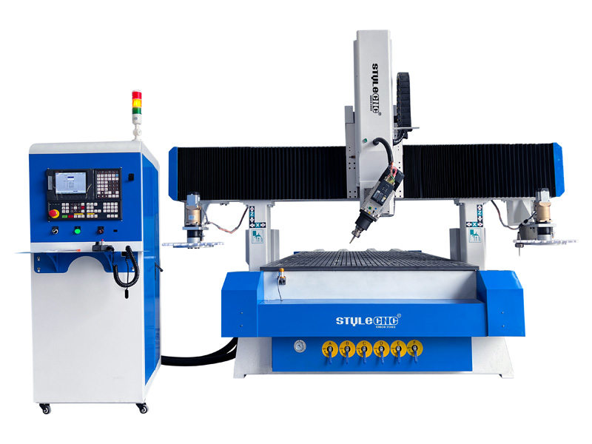

This additional rotation enables the router to cut at an angle, creating shapes with overhangs on two sides of the workpiece, rather than only from the top down, allowing it to create more intricate shapes [8].

##### Index/ Simultaneous (also sometimes called Continuous)

There are two types of 4-axis routers [9]:

1. Index Routers: These rotate the tool head and fix it at a particular A-axis position before cutting the workpiece.
2. Simultaneous Routers: These can rotate the tool head while cutting the workpiece, allowing for more efficient and complex shape creation.

Index routers are less complex and simpler to program but take longer to create complex shapes. In contrast, simultaneous routers are harder to program but can create complex shapes efficiently by immediately moving the Router to the optimal positions [9].

#### 5-Axis Routers

|  |
| --- |
| Fig. 3 5-axis Router. Adapted from [10] |

A 5-axis router introduces two new additional axes, typically called the B and C axes. The tool head can rotate around these two axes, with the B-axis rotating along the Y-axis and the C-axis rotating along the Z-axis [11].

With these two additional axes, a 5-axis router can now cut the workpiece from all sides and angles (except under the workpiece), allowing the router to create complex shapes [9].

##### 3+2 Axis/ Simultaneous 5-Axis (also sometimes called Continuous)

There are two types of 5-Axis routers [9]:

1. 3+2 Axis Routers: These rotate the tool head and fix it at specific positions along the B and C axes before cutting the workpiece.
2. Simultaneous Routers: These rotate the tool head while cutting the workpiece.

The former is less complex and simpler to program but will take longer to create complex shapes, while the latter is more complex and harder to program but can create complex shapes efficiently by moving the Router to the optimal positions immediately [11].

## What is a CNC Mill?

A CNC Mill is a sturdy and powerful manufacturing machine capable of working with both soft materials such as foam and wood, and hard materials like various metals [12]. CNC Mills offer extreme precision, and depending on the number of axes, can carve more complex 3Dshapes [1].

## What is the Difference Between a CNC Router and a CNC Mill?

CNC Routers and CNC Mills are two names that are used interchangeably. However, they have significant differences.

As a general overview, the differences are (but not limited to):

1. Stability: Due to the designs of CNC Mills, they are more stable and less prone to vibrations. This gives them higher rigidity and allows for more accurate machining.
2. Speed: CNC Routers typically operate at higher RPMs, allowing them to cut through material faster. However, the higher speed reduces the router's accuracy compared with the CNC Mill. As a result, the Router cannot handle harder materials.
3. Working Area: CNC Routers typically have a larger working area, allowing them to manufacture larger parts, while CNC Mills are typically smaller.

Both CNC Machines have their strengths and weaknesses. They are designed for two different purposes, excelling individually in their intended applications. Choosing the correct machine is vital for manufacturing the correct product in the best manner [13], [14].

## 

## Coordinate Systems for CNC Machines

Understanding the coordinate system is vital for proper understanding, programming and operation of CNC machines.

Here are the most important things to understand:

1. Types of Axes: The X, Y, Z, A, B and C axes. (There could be more, but they are not relevant to the scope of this project.) [9], [11]. Ensure that each axis is correctly identified for the proper operation of the machine; otherwise, you may accidentally take an unintended action, causing large amounts of damage.
2. Absolute/Relative Coordinates: When operating the machine, you may tell the machine to move in an absolute or relative coordinate system. Absolute moves the machine to a specific point in the machine, regardless of the current position of the tool head [15], [16]. For example, if you tell the machine to move to position (5, 2) on the X and Y axes, it will always move to that exact position. With relative, the machine moves relative to the tool head’s current position. For example, (5, 2) will move the tool head +5 along the X-axis and +2 along the Y-axis.
3. Home/ Origin Coordinates: This refers to the position where the absolute coordinate system’s (0, 0) will be positioned [15].
4. Work Coordinates: This refers to the position where the origin is defined relative to the workpiece [15]. The work coordinates can be the same or different from the machine's origin coordinate. It is especially useful when working on multiple parts, allowing programs to run relative to each part’s origin [15].
5. Tool Coordinates: This is vital for indicating the length of the tool and the position of the cutting head relative to the tool head [15].

## 3D Printers are CNC Machines?

Yes, 3D printers are a type of CNC machine!

### Additive vs Subtractive Manufacturing

3D printers use additive manufacturing, while a machine such as a CNC Router uses subtractive manufacturing [17], [18].

3D printers are additive as instead of removing material from a part, they add material constantly to build it up, manufacturing in an additive fashion [17], [18], [19].

CNC Routers are subtractive manufacturing, as they remove material from a part, manufacturing in a subtractive fashion [17], [18].

Whenever material is added to create a part, it is additive. Whenever material is removed to create a part, it is subtractive.

# G-Code

## What is G-Code?

G-Code stands for “Geometric Code” and is the programming language used for CNC machines [20], [21]. G-Code tells the machine what to do, such as (but limited to) where to go, how fast to move, and how to turn on the system [20].

## How does it work?

G-Code operates linearly, running line by line from the top down [20]. The type of operation can be seen as a code, with “G” followed by a number. To see the types of G-Codes, please look at this link: <https://www.machinistguides.com/g-codes/>.

A G-Code file is structured as follows [22]:

1. Header - Sets the Router settings and any initial operations, such as (but not limited to) which coordinate system to use or what tool to change to.
2. Operations - The operations are included, with the G-Codes and parameters if applicable.
3. Footer - The last operation to do, such as moving back to the machine origin.

## Does G-Code differ between machines?

Yes, G-Code can sometimes differ between machines. Although G-Codes as a whole is a standardized programming language, manufacturers will sometimes create proprietary codes to do specific tasks.

Furthermore, between different types of CNC Machines, G-Code operations may differ. It is vital to always research the machine being used to ensure the correct codes are being executed [21].

# 

# Manufacturing process

## What is the Manufacturing process?

For the scope of this project, this document will focus only on the digital manufacturing process, continuing from when the part is now ready to be designed digitally and manufactured.

First, the part has to be created, which will be done using CAD, whose purpose is to create the part. Afterwards, CAM will be used to generate the G-Code tool path to manufacture the part. Lastly, the G-Code is then put into a manufacturing machine to manufacture the part.

To explain the tools, let's use an example - the user is attempting to create a solid foam box. It has two parts, a lid, and the box body, to be manufactured using a 5-axis CNC Router.

For this product, there are two parts and one assembly. The two parts are of course the lid, and the body of the box, while the assembly is the combined lid with the box body.

## What is CAD?

CAD stands for Computer Aided Design. In simple words, it is used to create a computer model for the part the user is trying to create [23], [24].

### What does it do? What is it for?

The primary function of CAD is to design the part, but there are many features in modern CAD software to help the user design the best part. The user can run simulations to ensure it holds up to the correct strength, render the part so that the part can be visualized in a real setting, and run many additional functions [23], [24]. Another key feature is the ability to make “assemblies” [23], [24]. An assembly file is where you take all the parts of a product, and put it together, to ensure it all works together.

### Example

Using the foam box example, after you create your lid and box body, you can create a new file, import both the lid and box body file, and test to see if the part fits together. That’s an assembly file [23], [24].

## What is CAM?

CAM stands for Computer Aided Manufacturing. It takes in a file made in CAD, and generates the G-Code tool path the machine has to use to manufacture the part [25], [26].

### What does it do? What is it for?

The primary function of CAM is to create the G-Code tool path that can be passed on to the appropriate machine to manufacture the part [25], [26]. There are many features in modern CAM software to help the user create the ideal path. The user can run simulations to visualize what the tool path will look like, and optimize the correct speed to cut based on the material and cutting bit [26]. If it is too fast, it can damage the tool bit, the part, or at times even the machine itself.

### Example

Using the foam box example, you can import one of the parts, let's say the lid, and generate the tool path to create the part. After entering all of the correct parameters, the user can then simulate the tool path to visualize it, and ensure there are no errors, before creating the finished G-Code file and inputting it in the CNC Router to manufacture it [26].

## 

# Arma Automotive Inc. CNC Router

## Machine Specifications

The custom-made CNC Router in Arma Automotive is classified as a simultaneous 5-axis CNC Router. However, as of the writing of this document, it will be used and developed as if it were a 3+2 axis Router, due to the reduction in complexity, and speed of the B and C axis motors.

More details unavailable, awaiting additional specifications from Arma Automotive Inc.

# 

# Bit Selection UI

## Feature Description

There was a problem where the user could enter only one configuration for a cutting bit, which does not save an entered value.

As a solution for this, we updated the UI so the user can select 6 different bits using JComboBox, and then enter and save different values for various use cases.

Bit Selection (left), Bit Form (right)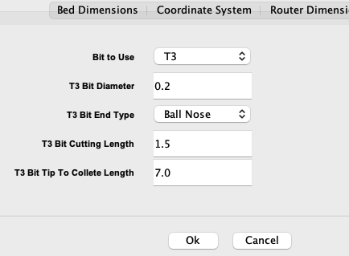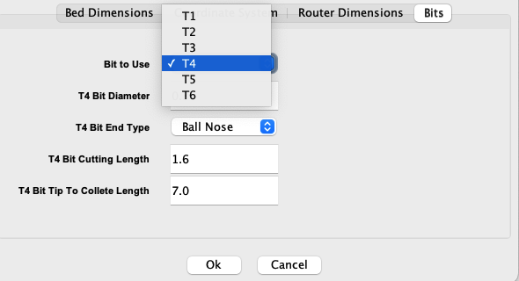

## Version History

| **Version** | **Date** | **Description** | |
| --- | --- | --- | --- |
| 1.0 | Nov. 09, 2024 | Completed | |

## Implementation Documentation (Version 1.0)

Made an ArrayList that stores tool names and used that for the property file name to store information for each bit.

There were no outstanding issues or obstacles during the implementation of this feature. In the feature review session among the team, we came up with 2 ideas for potential improvement: creating another UI for adding additional bits, and having a descriptive name for each bit either by autogenerating the bit name based on values or having a new field for bit description. We did not implement those features since the sponsor marked them as low-priority tasks.

## Next Steps

We will work on more UI modifications based on specification.

# UI Organization with Tab

## Feature Description

The form for entering router configuration was not organized in that it was listing all the fields in a single tab.

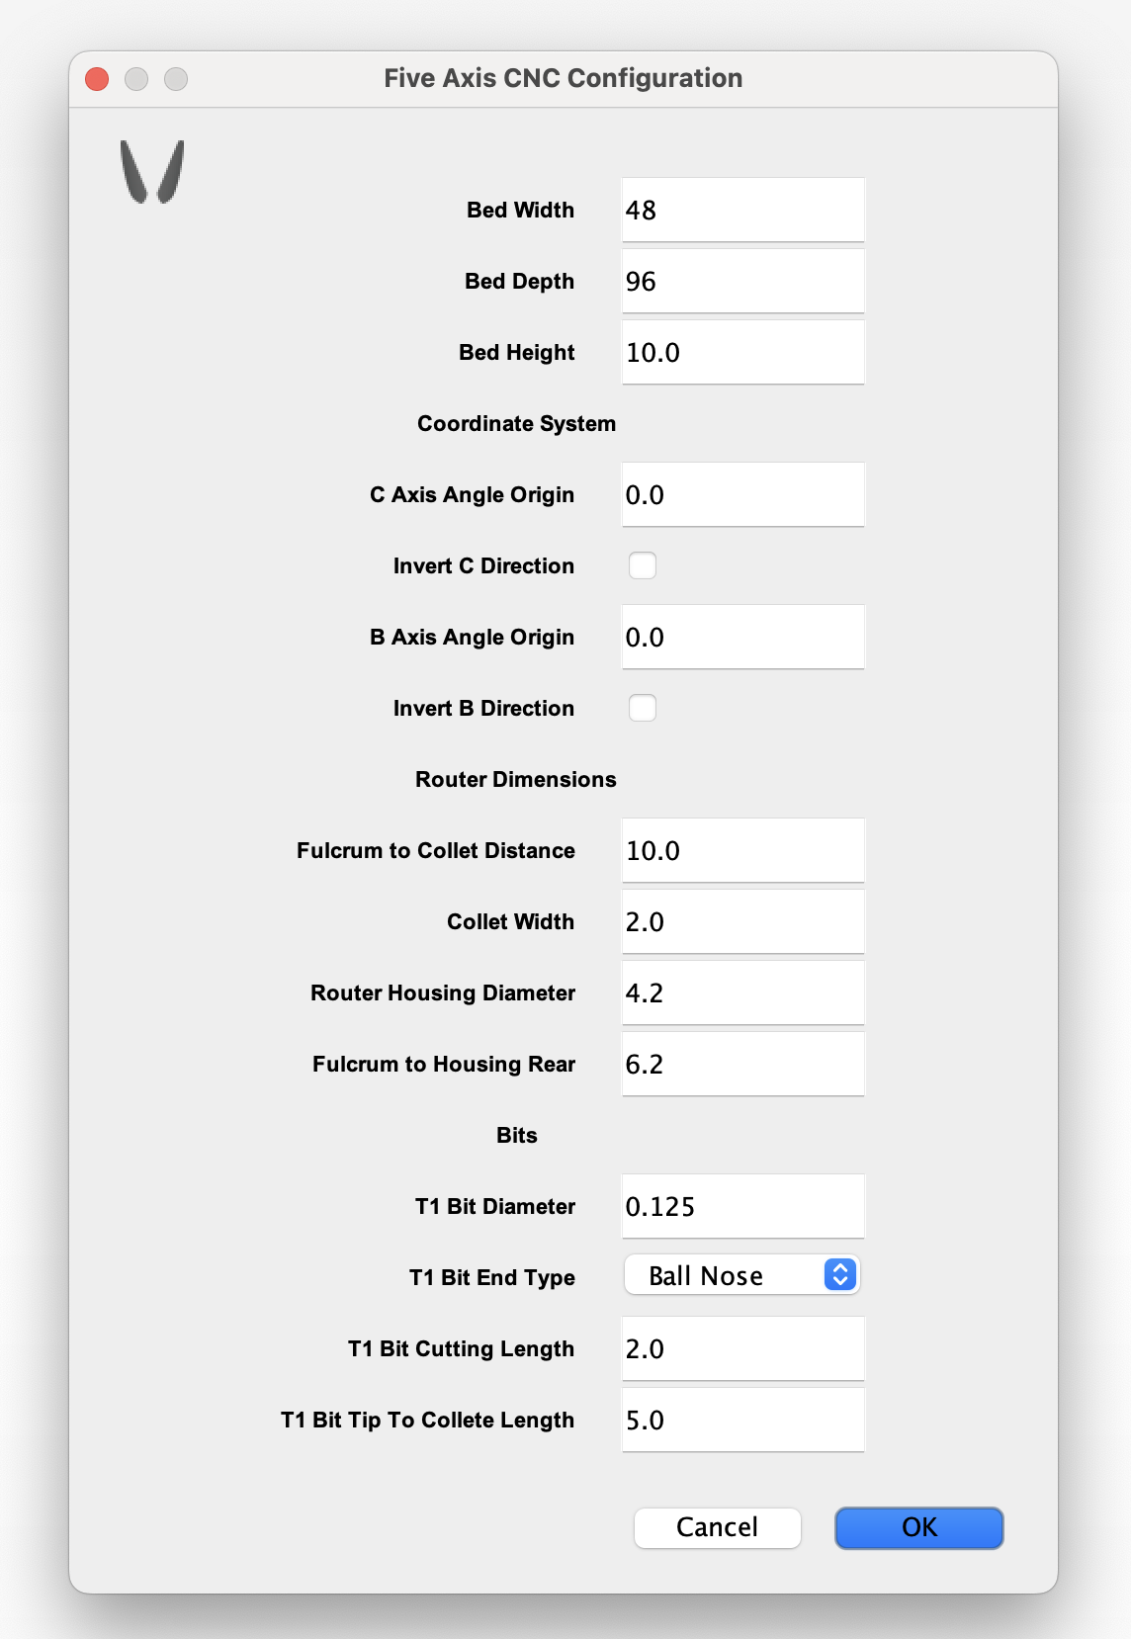

To organize the form, we used JTabbedPane to separate different fields by multiple tabs that the user can navigate through. The image on the left depicts the original version of the form, while the bottom showcases the updated version.

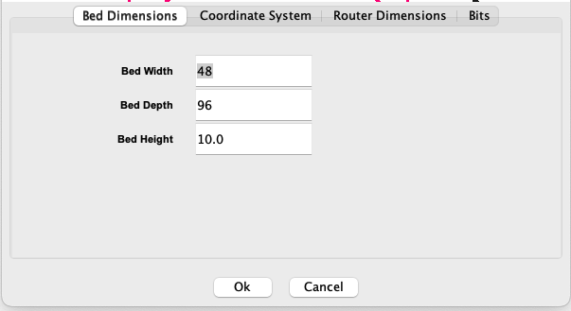

Original Form (left), Organized Form (right)

## Version History

| **Version** | **Date** | **Description** | |
| --- | --- | --- | --- |
| 1.0 | Nov. 09, 2024 | Completed | |

## Implementation Documentation (Version 1.0)

Stored multiple panels to a single JTabbedPane to organize related fields instead of putting them on a JPanel.

We had a minor issue where the JTabbedPane were not showing up as we intended, but it was fixed by eliminating the original JPanel used for holding every field.

## Next Steps

After organizing the UI, we started working on saving and loading router configuration data for Examples.java.

# Save Router Configuration to Properties File and Apply in Examples.java

## Feature Description

In the router configuration form, the data the user enters is not saved, but rather hardcoded; therefore, we made the program to save the data from the form and apply the saved value in the toolpath generation program.

The process involved updating the code to serialize the router configuration values into a properties file and adding functionality to load these settings back into Examples.java.

## Version History

| **Version** | **Date** | **Description** | |
| --- | --- | --- | --- |
| 1.0 | Nov. 10, 2024 | Completed | |

## Implementation Documentation (Version 1.0)

In the FiveAxisConfig.java and Examples.java, used java.util.Properties to store and load the router configuration information to cam.properties file. After finalizing this feature, we began testing it to ensure compatibility with other functionalities in Examples.java.

There were no outstanding issues. For this type of feature, testing became the essential process since there are various cases that potentially cause bugs, such as FileNotFoundException.

## Next Steps

We started working on saving and applying cutting configuration values.

# 

# Save Cutting Configuration to Properties File and Apply in Examples.java

## Feature Description

The software had the same issue for the cutting configuration form where it did not save the user input. We updated the code to store cutting configuration values (Speed, Max Depth, and Tool Selection) in a properties file for persistence and applying them during execution in Examples.java. This ensures that cutting parameters are consistent and reusable across sessions.

## Version History

| **Version** | **Date** | **Description** | |
| --- | --- | --- | --- |
| 1.0 | Nov. 10, 2024 | Completed | |

## Implementation Documentation (Version 1.0)

Took a very similar approach to what we did for FiveAxisConfig.java. Instead, this feature focuses on the ThreePlusTwoPrompt.java and Examples.java. Refer to the previous feature for more information.

Implementing this feature took a lot less than the previous task due to the similarity.

## Next Steps

In the meeting, the sponsor pointed out saving property files in a folder instead of the project root directly.

# 

# Create Property File Folder if Missing

## Feature Description

Automatically checks for the existence of the properties file folder and creates it if it does not exist instead of creating it at the project root folder, ensuring proper file organization and functionality.

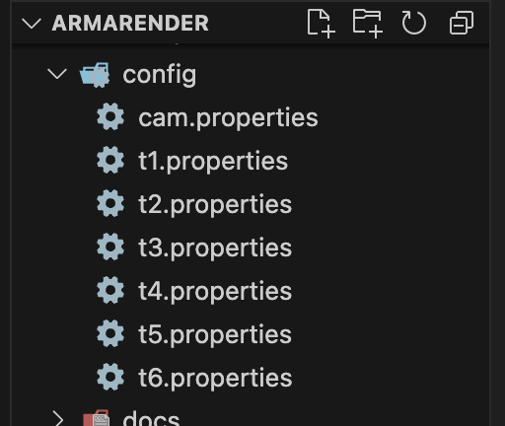

config folder that has all property files

## Version History

| **Version** | **Date** | **Description** | |
| --- | --- | --- | --- |
| 1.0 | Nov. 21, 2024 | Completed | |
| 1.1 | Nov. 28, 2024 | Changed folder name from Properties to config | |

## Implementation Documentation (Version 1.1)

In FiveAxisConfig.java and ThreePlusTwoPrompt.java, when the forms load the data from files, if the file path is not found at loadProperties function, it calls createEmptyPropFile function that checks if the folder exists before creating a new file.

This feature was straightforward to implement since we needed to add only one logic to check if the folder exists and change the file paths. This experience made it clear how modularizing code can help future developers maintain or update code.

## 

## Next Steps

As one big feature for complete prototype software, the sponsor wanted to construct realistic geometry for their CNC Router when running the simulation.

# Router Geometry Construction

## Feature Description

When running the simulation, the geometry of the CNC Router was not realistic and accurate, which made collision detection less accurate. To address that, we recreated the geometry of the CNC Router based on the specifications that the sponsor provided.

The code implements the logic to define, configure, and construct router dimensions through the router configuration form, ensuring they are accurately set for various operations.

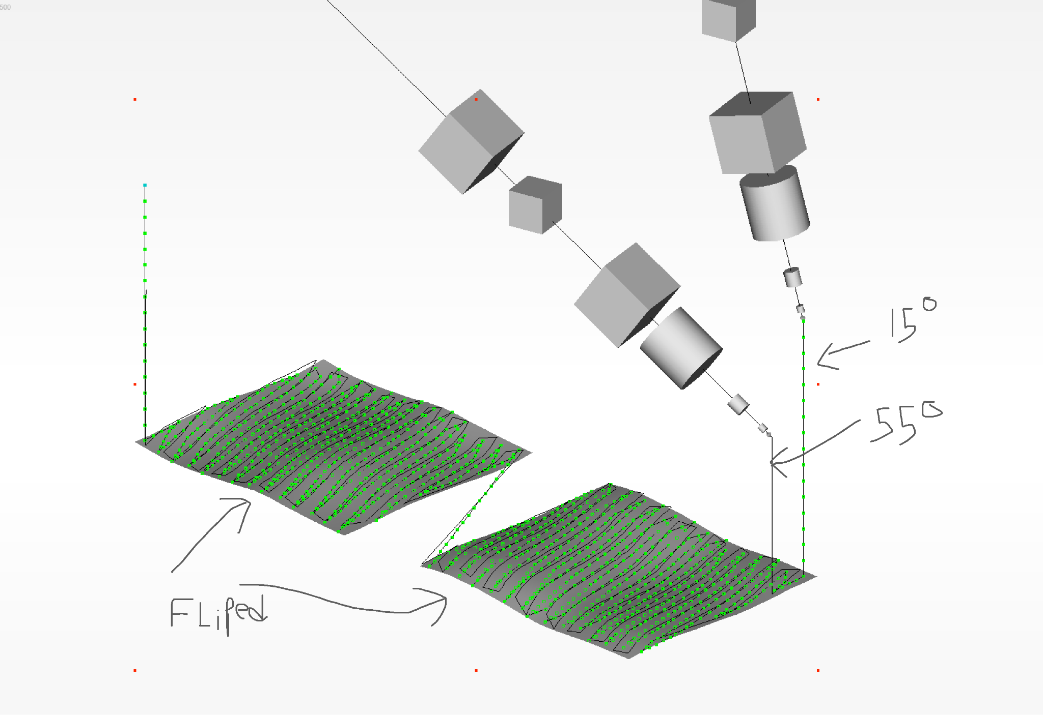 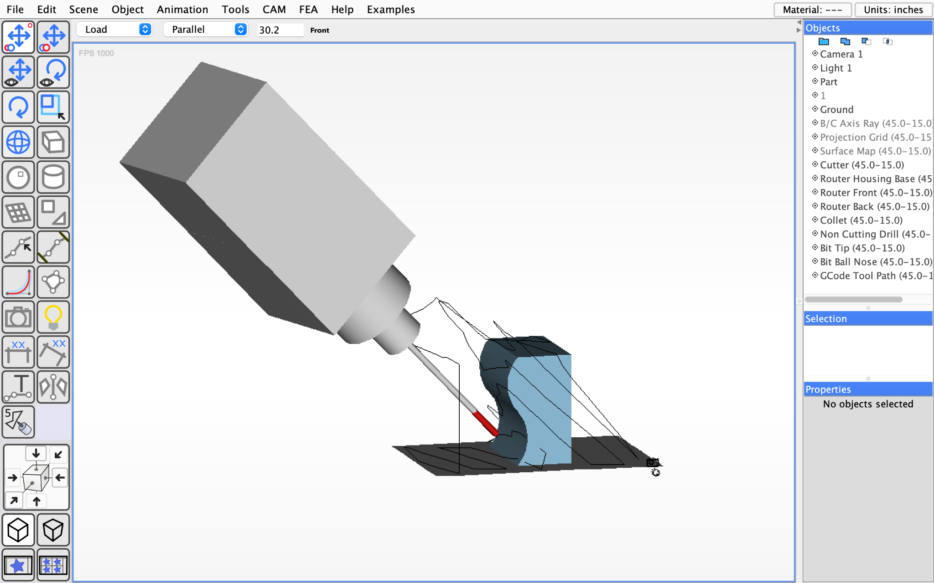

Original router geometry (left), Updated router geometry (right)

## Version History

| **Version** | **Date** | **Description** | |
| --- | --- | --- | --- |
| 1.0 | Nov. 19, 2024 | Initial geometry completed | |
| 1.1 | Nov. 20, 2024 | Added non-cutting bit between the collet and cutting bit | |
| 1.2 | Nov. 21, 2024 | Coloured tool bit to red | |
| 1.3 | Nov. 25, 2024 | Refactored the construction code to a function so that it works at both finishing and roughing program | |

## Implementation Documentation (Version 1.3)

Router geometry construction is conducted at the constructRouterGeometry function. First, router configuration values from the cam.properties file are taken. Then geometry is constructed by placing ObjectInfo, which represents the shape of each part of the CNC Router, in the RouterElementContainer. After that, it colours the tooltip to red using Texture.

The sponsor gave us the specification of how the updated router geometry looks like and its size in inches.

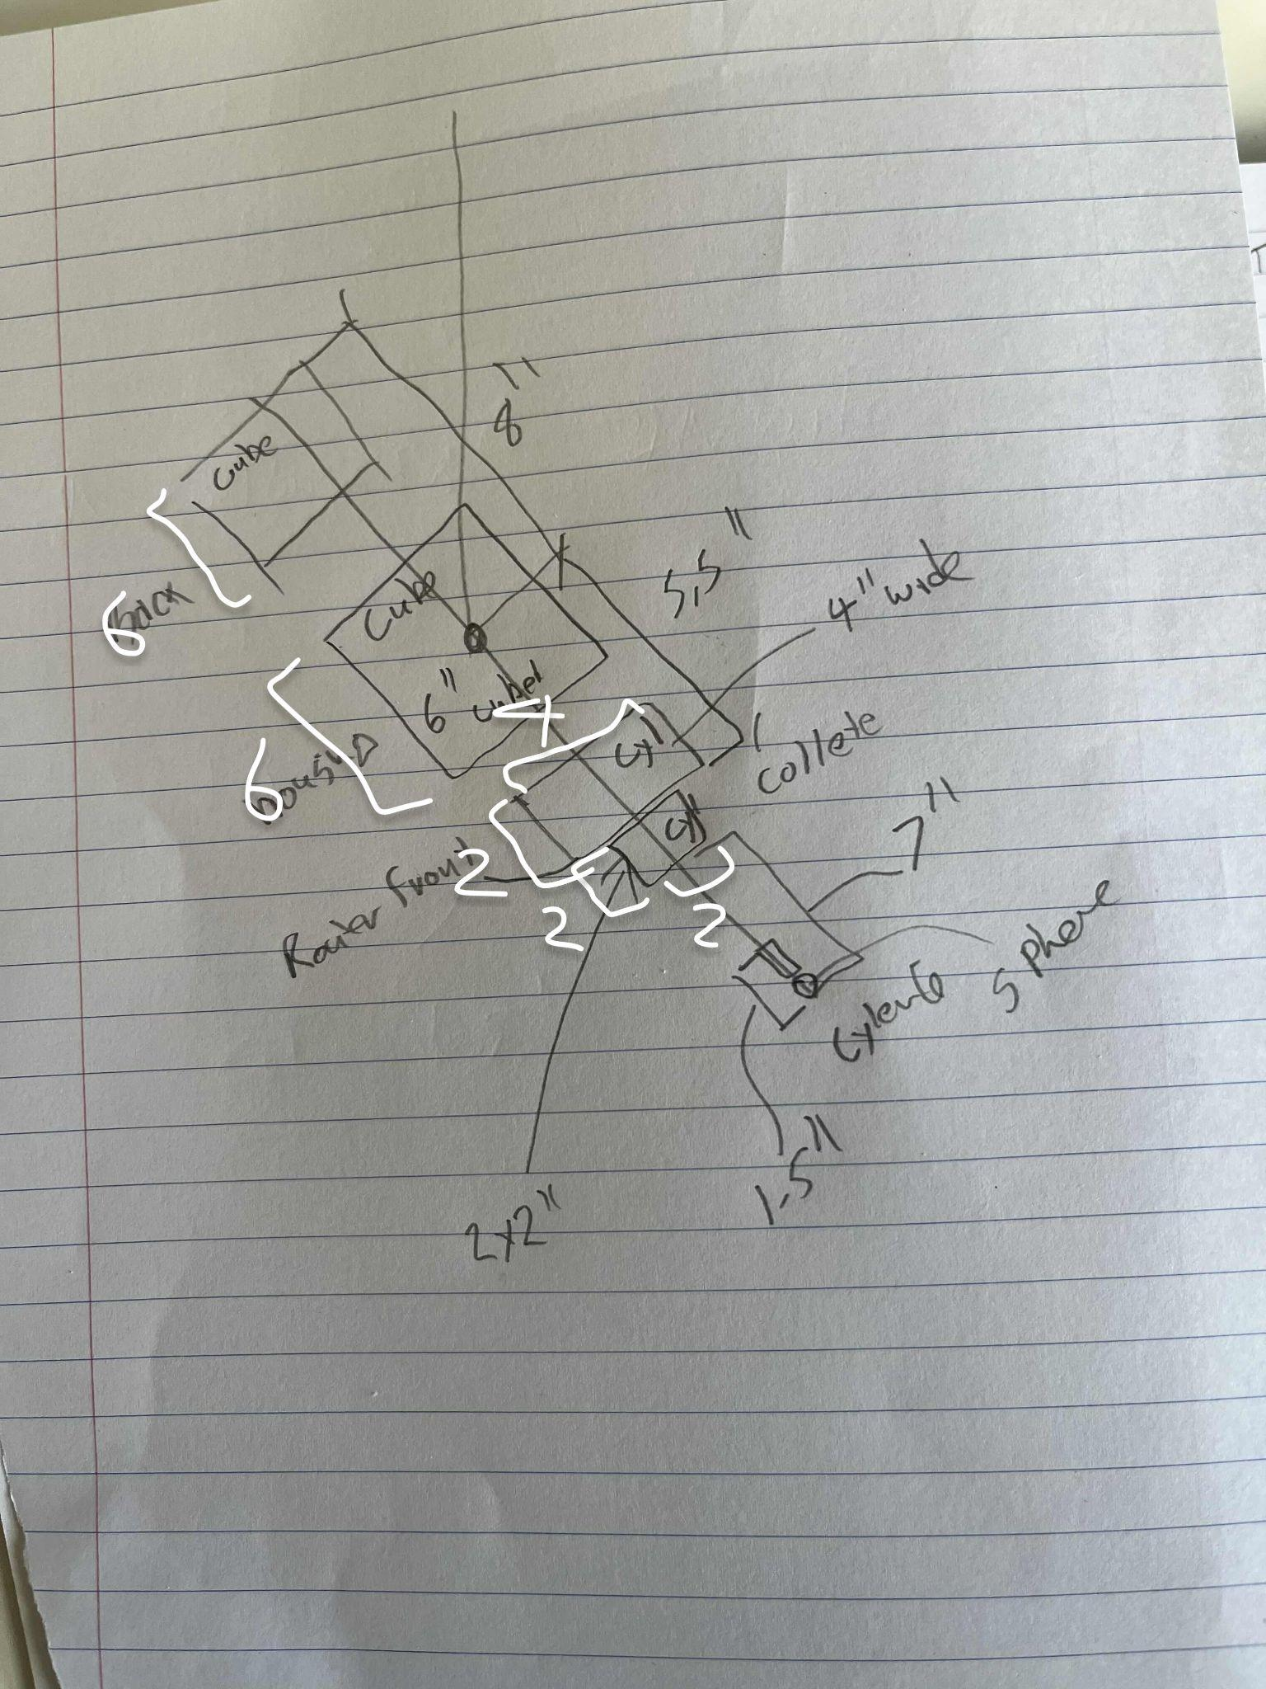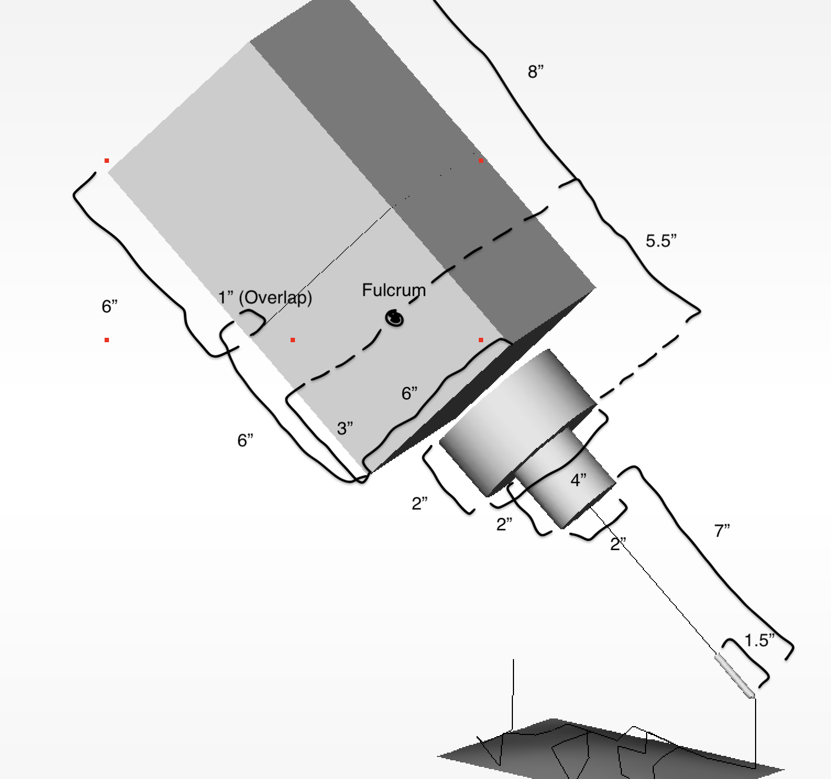

Specification sketch (left), Actual product based on specification (right)

We had trouble properly placing cylinder shapes of a specified size and position. This was happening because they were using differnt reference points when the program indicates their position. This changed the position of cylinder shapes when they were using different widths. Refer to the constructRouterGeometry function for detailed information.

This feature especially requires lots of variables to be used; therefore, naming them properly based on how they are used and what they represent helped me understand and write code drastically.

## Next Steps

We realized the objects from the previous run were not destroyed when running the toolpath generation program again. (both finishing and roughing)

# 

# Clear Scene Before Running, Finishing or Roughing Program Again

## Feature Description

Ensures the scene is cleared of previous data or configurations before executing finishing or roughing operations again, preventing having multiple router geometries in a scene and any potential errors.

## Version History

| **Version** | **Date** | **Description** | |
| --- | --- | --- | --- |
| 1.0 | Nov. 27, 2024 | Completed | |

## Implementation Documentation (Version 1.0)

removeGeneratedObjectsFromScene removes unnecessary generated objects from the scene for the second run. It simply removes scene objects whose material ID is 500, and then updates the UI to reflect the change.

There were no outstanding issues during working on this feature.

## Next Steps

During the time frame of the Capstone project, we decided to work on several more features.

# 

# Add RPM Field to ThreePlusTwoPrompt.java

## Feature Description

Include a field to input or display RPM (Revolutions Per Minute) within the ThreePlusTwoPrompt.java interface for G-Code generation, enhancing user control and customization options.

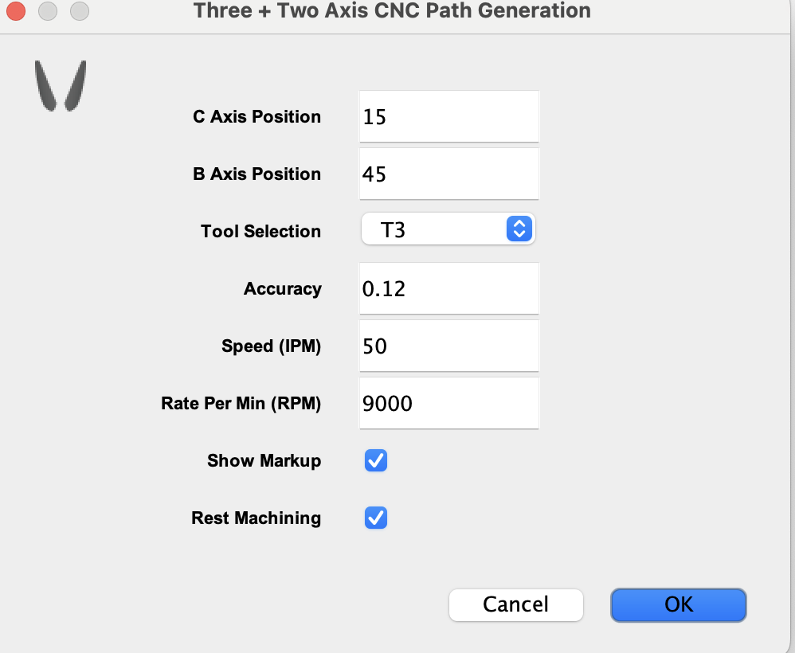

RPM Field added to form

## 

## Version History

| **Version** | **Date** | **Description** | |
| --- | --- | --- | --- |
| 1.0 | Nov. 27, 2024 | Completed | |

## Implementation Documentation (Version 1.0)

Fairly straightforward to implement since ThreePlusTwoPrompt.java have all the other fields that are saved and applied in the same way. We made sure it was properly integrated by checking the generated G-code.

## Next Plans

Currently None.

# References

1. "What is CNC? Complete CNC Guide for 2023," CNCSourced. [Online]. Available: <https://www.cncsourced.com/guides/what-is-cnc-complete-cnc-guide/> [Accessed: Oct. 30, 2023].
2. "What is a CNC Machine," CNCMachines.com, 2024. [Online]. Available: <https://cncmachines.com/what-is-a-cnc-machine> [Accessed: Oct. 30, 2023].
3. "What is CNC Machining?," CNC Philosophy. [Online]. Available: <https://cncphilosophy.com/what-is-cnc-machining/> [Accessed: Nov. 23, 2024].
4. P. Jacobs, "CNC Routers: A Guide for Beginners," CNC Machines, Nov. 23, 2023. [Online]. Available: [https://www.cncmasters.com/cnc-Routers/](https://www.cncmasters.com/cnc-routers/) [Accessed: Nov. 23, 2023].
5. T. Shelton, "X, Y, and Z Axis Stand Explained," ACOEM, Feb. 1, 2018. [Online]. Available: <https://acoem.us/blog/other-topics/x-y-z-axis-stand/> [Accessed: Nov. 23, 2024].
6. EngineeringClicks, "Understanding CNC Axes," Mechanical Engineering, Jan. 15, 2020. [Photo]. Available: <https://mechanical-engineering.com/3-4-5-axis-cnc/> [Accessed: Nov. 23, 2024].
7. "4-Axis CNC Router with Rotary Fixed Table," StyleCNC. [Photo]. Available: [https://www.stylecnc.com/cnc-wood-Router/4-axis-cnc-Router-with-rotary-fixed-into-working-table.html](https://www.stylecnc.com/cnc-wood-router/4-axis-cnc-router-with-rotary-fixed-into-working-table.html) [Accessed: Nov. 23, 2024].
8. "What is the 4th Axis on a CNC Router?," Lunyee CNC. [Online]. Available: [https://www.lunyeecnc.com/blogs/faq/what-is-the-4th-axis-on-a-cnc-Router](https://www.lunyeecnc.com/blogs/faq/what-is-the-4th-axis-on-a-cnc-router) [Accessed: Nov. 23, 2024].
9. A. Lewis, "3, 4, and 5-Axis CNC Machine Router Guide," CNCSourced, Oct. 30, 2023. [Online]. Available: [https://www.cncsourced.com/guides/3-4-5-axis-cnc-machine-Router/](https://www.cncsourced.com/guides/3-4-5-axis-cnc-machine-router/) [Accessed: Nov. 23, 2024].
10. "Image of a CNC setup," Pinterest. [Photo]. Available: <https://www.pinterest.com/pin/67342956904598059/> [Accessed Nov. 23, 2024].
11. L. Watts, "CNC Terminology and Definitions," CNCSourced, Feb. 13, 2024. [Online]. Available: <https://www.cncsourced.com/cnc-machining/cnc-terminology-definitions/>   
    [Accessed: Nov. 23, 2024].
12. "What is a CNC Milling Machine?," CNCLathing, Dec. 19, 2019. [Online]. Available: [https://www.cnclathing.com/guide/what-is-a-cnc-Milling-machine-how-does-it-work-types-of-cnc-Milling-machines](https://www.cnclathing.com/guide/what-is-a-cnc-milling-machine-how-does-it-work-types-of-cnc-milling-machines) [Accessed: Nov. 23, 2024].
13. P. Jacobs, "CNC Mill vs. Router: Differences Explained," CNC Masters, Feb. 28, 2023. [Online]. Available: [https://www.cncmasters.com/cnc-Mill-vs-Router-differences-explained/](https://www.cncmasters.com/cnc-mill-vs-router-differences-explained/) [Accessed: Nov. 23, 2024].
14. L. Watts, "CNC Routers vs. CNC Mills: Key Differences," CNCSourced, Feb. 20, 2024. [Online]. Available: [https://www.cncsourced.com/cnc-machining/cnc-Routers-vs-cnc-Mills-differences/](https://www.cncsourced.com/cnc-machining/cnc-routers-vs-cnc-mills-differences/) [Accessed: Nov. 23, 2024].
15. "Demystifying the CNC Machine Coordinate System: A Comprehensive Guide," SigmaTechnik. [Online]. Available: <https://www.sigmatechnik.com/cnc-factory/demystifying-the-cnc-machine-coordinate-system-a-comprehensive-guide> [Accessed Nov. 23, 2024].
16. "Understanding CNC Coordinate Systems," SigmaTechnik. [Online]. Available: <https://www.sigmatechnik.com/cnc-factory/understanding-the-cnc-machine-coordinate-system-a-comprehensive-guide> [Accessed: Nov. 23, 2024].
17. "Subtractive Manufacturing Explained," Market Business News. [Online]. Available: <https://marketbusinessnews.com/financial-glossary/subtractive-manufacturing/> [Accessed: Nov. 23, 2024].
18. "Additive vs. Subtractive Manufacturing," RapidDirect, Feb. 10, 2022. [Online]. Available: <https://www.rapiddirect.com/blog/additive-vs-subtractive-manufacturing/> [Accessed: Nov. 23, 2024].
19. R. Linke, "Additive Manufacturing Explained," MIT Sloan, Dec. 7, 2017. [Online]. Available: <https://mitsloan.mit.edu/ideas-made-to-matter/additive-manufacturing-explained> [Accessed: Nov. 23, 2024].
20. Dejan, "G-Code Explained: Commands for CNC," HowToMechatronics. [Online]. Available: <https://howtomechatronics.com/tutorials/g-code-explained-list-of-most-important-g-code-commands/> [Accessed: Nov. 23, 2024].
21. B. Fowler, "G-Codes: Essential Commands," Machinist Guides, Dec. 10, 2022. [Online]. Available: <https://www.machinistguides.com/g-codes/> [Accessed: Nov. 23, 2024].
22. "G-Code Programming for Beginners," CNC Philosophy. [Online]. Available: <https://cncphilosophy.com/g-code-programming-for-dummies/> [Accessed: Nov. 23, 2024].
23. 3DSourced. "What is CAD? An Introductory Guide," 3DSourced, Feb. 20, 2024. [Online]. Available: <https://www.3dsourced.com/guides/what-is-cad-guide-modeling/> [Accessed: Nov. 23, 2024].
24. "Technologies of CAD," PTC. [Online]. Available: <https://www.ptc.com/en/technologies/cad> [Accessed: Nov. 23, 2024].
25. M. Deans, "Fusion 360 and CAM for Beginners," Autodesk, Mar. 17, 2021. [Online]. Available: <https://www.autodesk.com/products/fusion-360/blog/computer-aided-manufacturing-beginners/> [Accessed: Nov. 23, 2024].
26. "What is CAM? Basics of Computer-Aided Manufacturing," GeeksforGeeks, May 14, 2024. [Online]. Available: <https://www.geeksforgeeks.org/what-is-cam-computer-aided-manufacturing/> [Accessed: Nov. 23, 2024].